



**SM6P07NI Digital Media Project**

**50% Project | 2025-26 Spring**

**Student Name: Sanket Shrestha**

**London Met ID: 22067428**

**College ID: NP01MM4A220103**

**External Supervisor: Rupesh Dangol**

**Internal Supervisor Parwat Bhujel**

**Assignment Due Date: Sunday, May 4, 2025**

**Assignment Submission Date: Wednesday, May 7, 2025**

**Word Count: 3418**

**Project File Links:**

|  |  |
| --- | --- |
| **Figma File Link:** |  |
| **Prototype Link:** |  |
| **One Drive Link:** |  |
| **Git Hub Link:** |  |

*I confirm that I understand my coursework needs to be submitted online via Google Classroom under the relevant module page before the deadline in order for my assignment to be accepted and marked. I am fully aware that late submissions will be treated as non-submission and a marks of zero will be awarded.*

**Abstract**

The SpaceChimp project was to design an accessible educational website which gives UI/UX design and motion graphics courses. The primary objective centered on designing an educational platform which would provide an intuitive and visually stunning experience for users utilizing multiple devices. The documentation includes detailed information about project development starting with sitemap creation and planning then continuing with wireframe development at low and high fidelity levels before Figma prototype completion.

Throughly accessibility test was done at the center of the entire designing journey. The accessibility tool Stark (Figma Plugin) enabled to evaluate contrast levels and font sizes while testing usability features which guaranteed the website worked for every user. The design maintained consistency while developing the brand identity through selections of intricate visual components such as colors, typography and illustrations.

Real users evaluated the design by completing surveys wihch was done using google form. The feedback shaped the final prototype so that it appeared attractive as well as simple to operate. The completed SpaceChimp platform successfully merged accessible functionality with well-designed elements to provide meaningful learning support.

**Contents**

1 Introduction 1

**Table of Figures**

**No table of figures entries found.**

# Introduction

## Project Title

Project Title: **SpaceChimp**

SpaceChimp is an educational institute providing courses like UI/UX Design, Motion Graphics, and Figma/Framer Design.

## Project Aim

The aim of this project is to design a fully responsive, adaptive and accessible website for SpaceChimp. The main goal of this project is to showcase the courses SpaceChimp offers and to get students enrolled in their institute through this website.

This project focuses on designing a user friendly website which aligns with the brand identity to boost course engagement and position SpaceChimp as one of the best educational institute in Nepal.

## Project Objectives

The main objective of this project is to get the answer for “How can responsive, adaptive, and accessible design collectively improve user engagement and inclusivity on educational websites?”

To get the answer for this, the project involves:

* Research on design trends and other educational platforms
* Designing of wireframes and prototypes in Figma
* Designing a consistent website which aligns with the brand identity
* Implementing basic animations
* Maintaining the content hierarchy
* Doing user testing and creating a adaptive and accessible website for all

## Unique Selling Point

SpaceChimp distinguishes itself through its specialization of design education with content developed by industry professionals. SpaceChimp provides accessible design education through high-quality visual elements alongside local content and interface design that makes learning comfortable for users from different backgrounds. SpaceChimp provides learners with an immersive educational experience through mentor-led sessions and real project briefs and its user-centric interface.

# Client Overview

## Client Background

The Nepal-based educational platform SpaceChimp delivers UI/UX design together with motion graphics along with Figma/Framer design. The company delivers industry-focused training by using mentors who guide practical lessons and real-world projects.

Managing director, Sandeep Shrestha at SpaceChimp works to build an open and creative educational space that supports young design students. The client needed a website design which is visuals attractive with straightforward navigation while ensuring accessibility to all users.

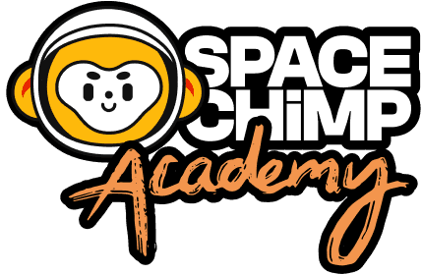

Figure 1: SpaceChimp Logo

## Project Requirements and Expectations

SpaceChimp’s main requirement for the website project involved building responsive accessibility features alongside design elements that present both the creative essence of the company and an intuitive user navigation system. The design needed to feature:

* The website displays fluid layout systems which adapt their design for every screen dimension.
* A straightforward navigation system will decrease user friction.
* The website implements features that make it accessible for users with different abilities to use it easily
* A visually engaging design combined with brand consistency needs to establish a professional image of the platform.

The websites was mainly focused for people who fall within the age range of 16 to 30 and belong to every gender angle including students and professionals at their initial stages who examine UI/UX design principles. Usability stood as a central focus because the project needed to accommodate users with different digital literacy skills.

# Project Timeline

The project of SpaceChimp was started with a Gantt Chart project plan that divided work into research then design then testing and at last monitoring and review before the project's end. The project structure included a plan which balanced workflow activities while meeting deadlines for all assigned tasks.

**Timeline Comparison:**

**Initial Timeline:**

The research by Gantt Chart indicated that the Design Phase would finish on March 25. The testing phase combined with final adjustments would continue from the late march through mid-April for creating appropriate documentation.

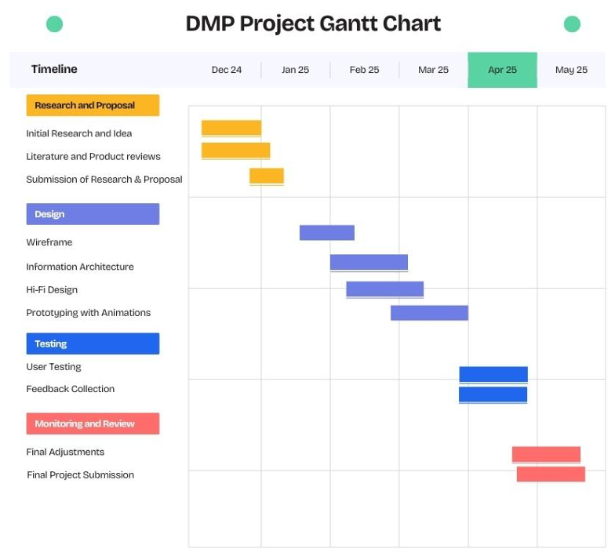

Figure 2: Initial Gantt chart

**Updated Timeline:**

The extensive design-related work necessitated longer execution of the Design Phase until April 25 because of increased requirements for accessibility and adaptability. Testing along with Final Adjustments within this phase needed intense work between April 26 and May 6 ahead of the May 7 deadline.

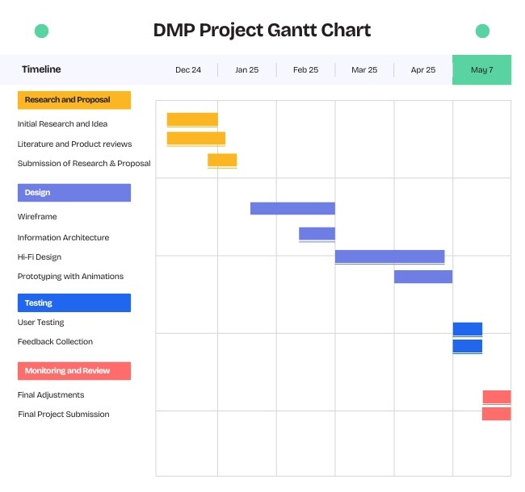

Figure 3: Final Gantt Chart

The schedule modification demonstrates a new priority to enhance design quality along with user experience before tackling final optimization. An important adjustment became necessary in order to match the outcome with the principal research questions together with design benchmarks.

# Planning and Production Process

## Research and Discovery

### Proposal Letter

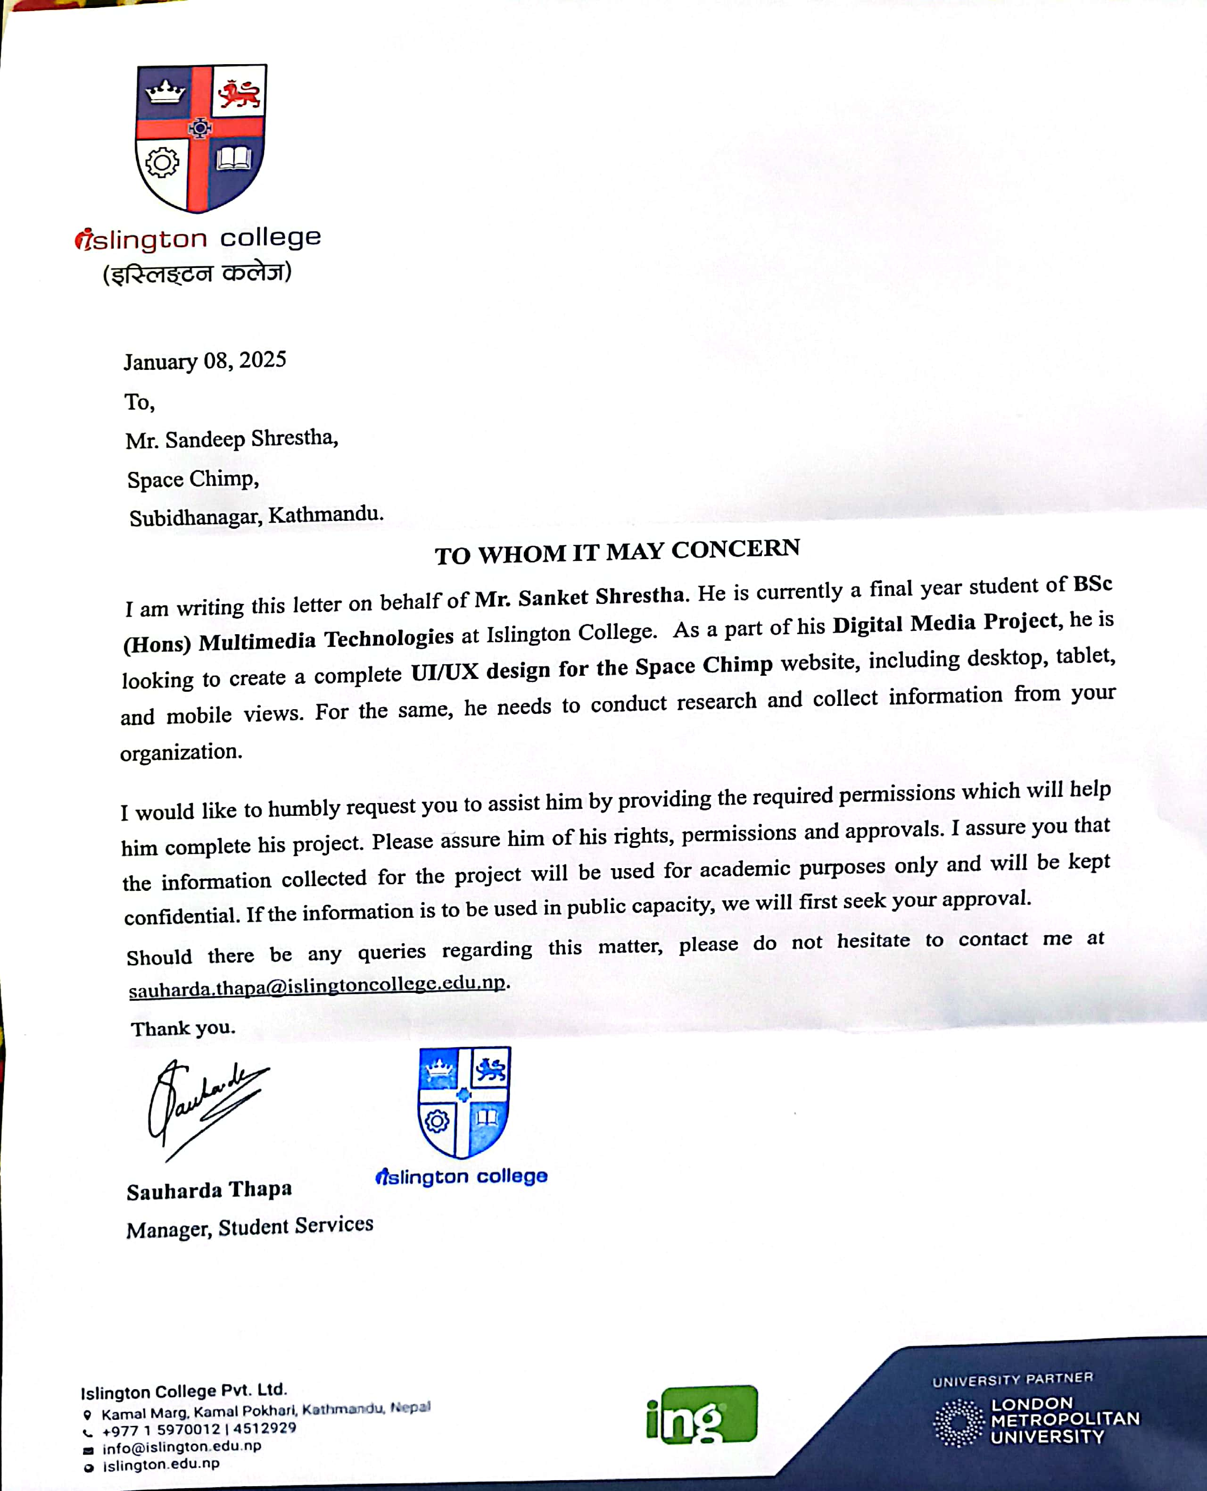

Figure 4: Proposal Letter

### Proposal Acceptance

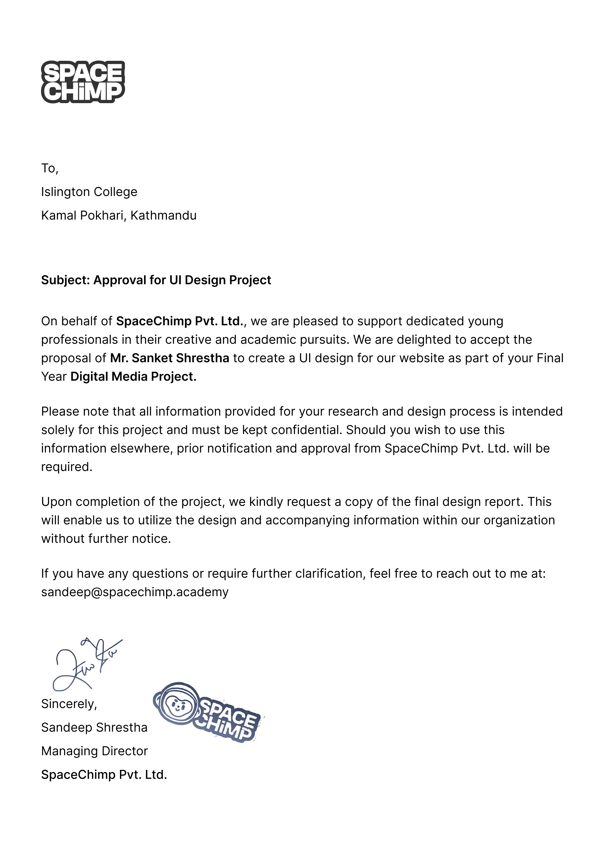

Figure 5: Proposal Acceptance Letter

### Research

The core research component of this project revolved around the following question:

"**How can responsive, adaptive, and accessible design collectively improve user engagement and inclusivity on educational websites?** "

The research for SpaceChimp is divided into two main sections to analyze this core question.

### Responsive, Adaptive, and Accessible Design Principles

Most of the conducted research concentrated on deepening the comprehension of responsive design principles along with adaptive design and accessibility features. An essential segment of research looked at maintaining visual consistency between multiple platforms across various screen dimensions as well as adapting layouts to adapt to differing screen sizes and applying WCAG guidelines for supporting users with unique needs. The analysis covered flexible grids together with media queries and alt text usage and color contrast and keyboard navigation to improve system usability and support inclusiveness.

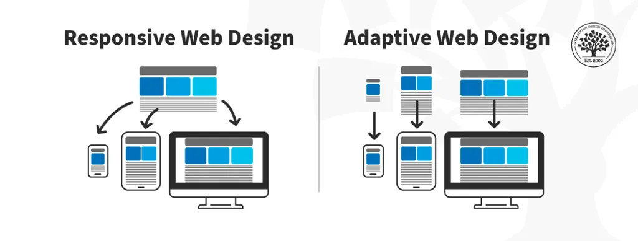

Figure 6 Responsive and Adaptive Web Design (Interaction Design Foundation, n.d.).

### UI/UX Design for Educational Engagement

This project dedicated specific attention to studying how interface and experiential design elements impact learning participation and involvement. The analysis examined layout structures as well as interactive components and animation usage together with visual hierarchy elements which improve user flow and comprehension. Designers focused particularly on minimalistic interfaces with limited distractability and strategic visual elements that improve focus and foster brand identity and create positive learning settings.

### Competitor Analysis

A competitor analysis focused on educational websites was done to help create a useful and intuitive educational website for SpaceChimp. The information help to serve as a guidance for the development of the final web design principles alongside functionality elements.

## Broadway Infosys:

Broadway Infosys operates as one of the prominent IT training institutes throughout Nepal. SpaceChimp presents their website with an organized course layout and simple navigation through a clean interface. The layout system of SpaceChimp was shaped by prominent CTA button design and hierarchical content organization. SpaceChimp adopted their strategy of popular course emphasis along with expedient access to vital information to guide their homepage and course page organization.

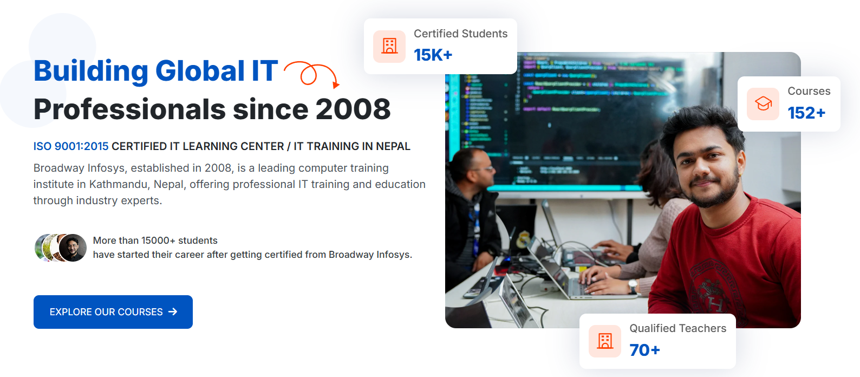

Figure 7: Hero Section of Broadways Infosys

## Skillshare:

The online learning platform Skillshare provides high-quality design and a great user experiences for its global market. The platform creates an inviting learning space because they implement engaging visuals alongside clear typography and consistent color schemes. SpaceChimp incorporated a well-structured table of contents of each courses this helped users to easily navigate thorugh the course and understand the learning process.

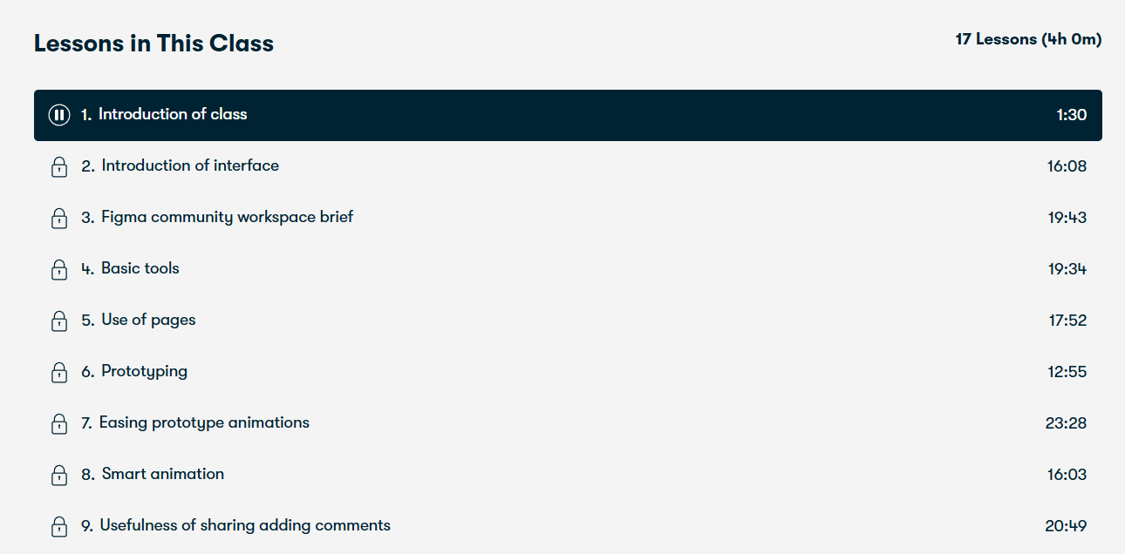

Figure 8: Class Content of Skill Share

The analysis of these platforms led to critical design decisions in SpaceChimp for presenting both visual attractiveness and functional capability through enhancements of accessibility and user engagement.

### User Persona Development

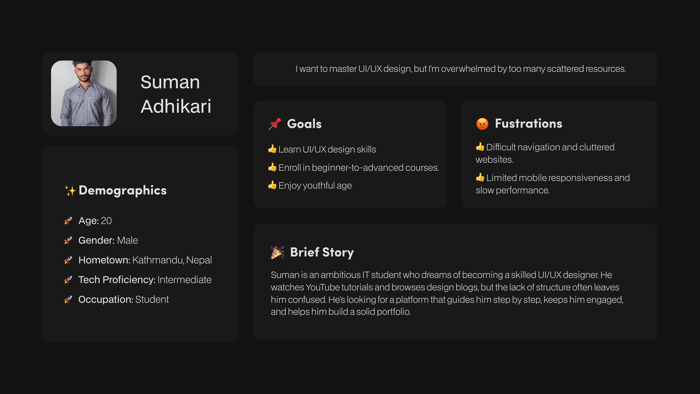

Figure 9: User Persona 1

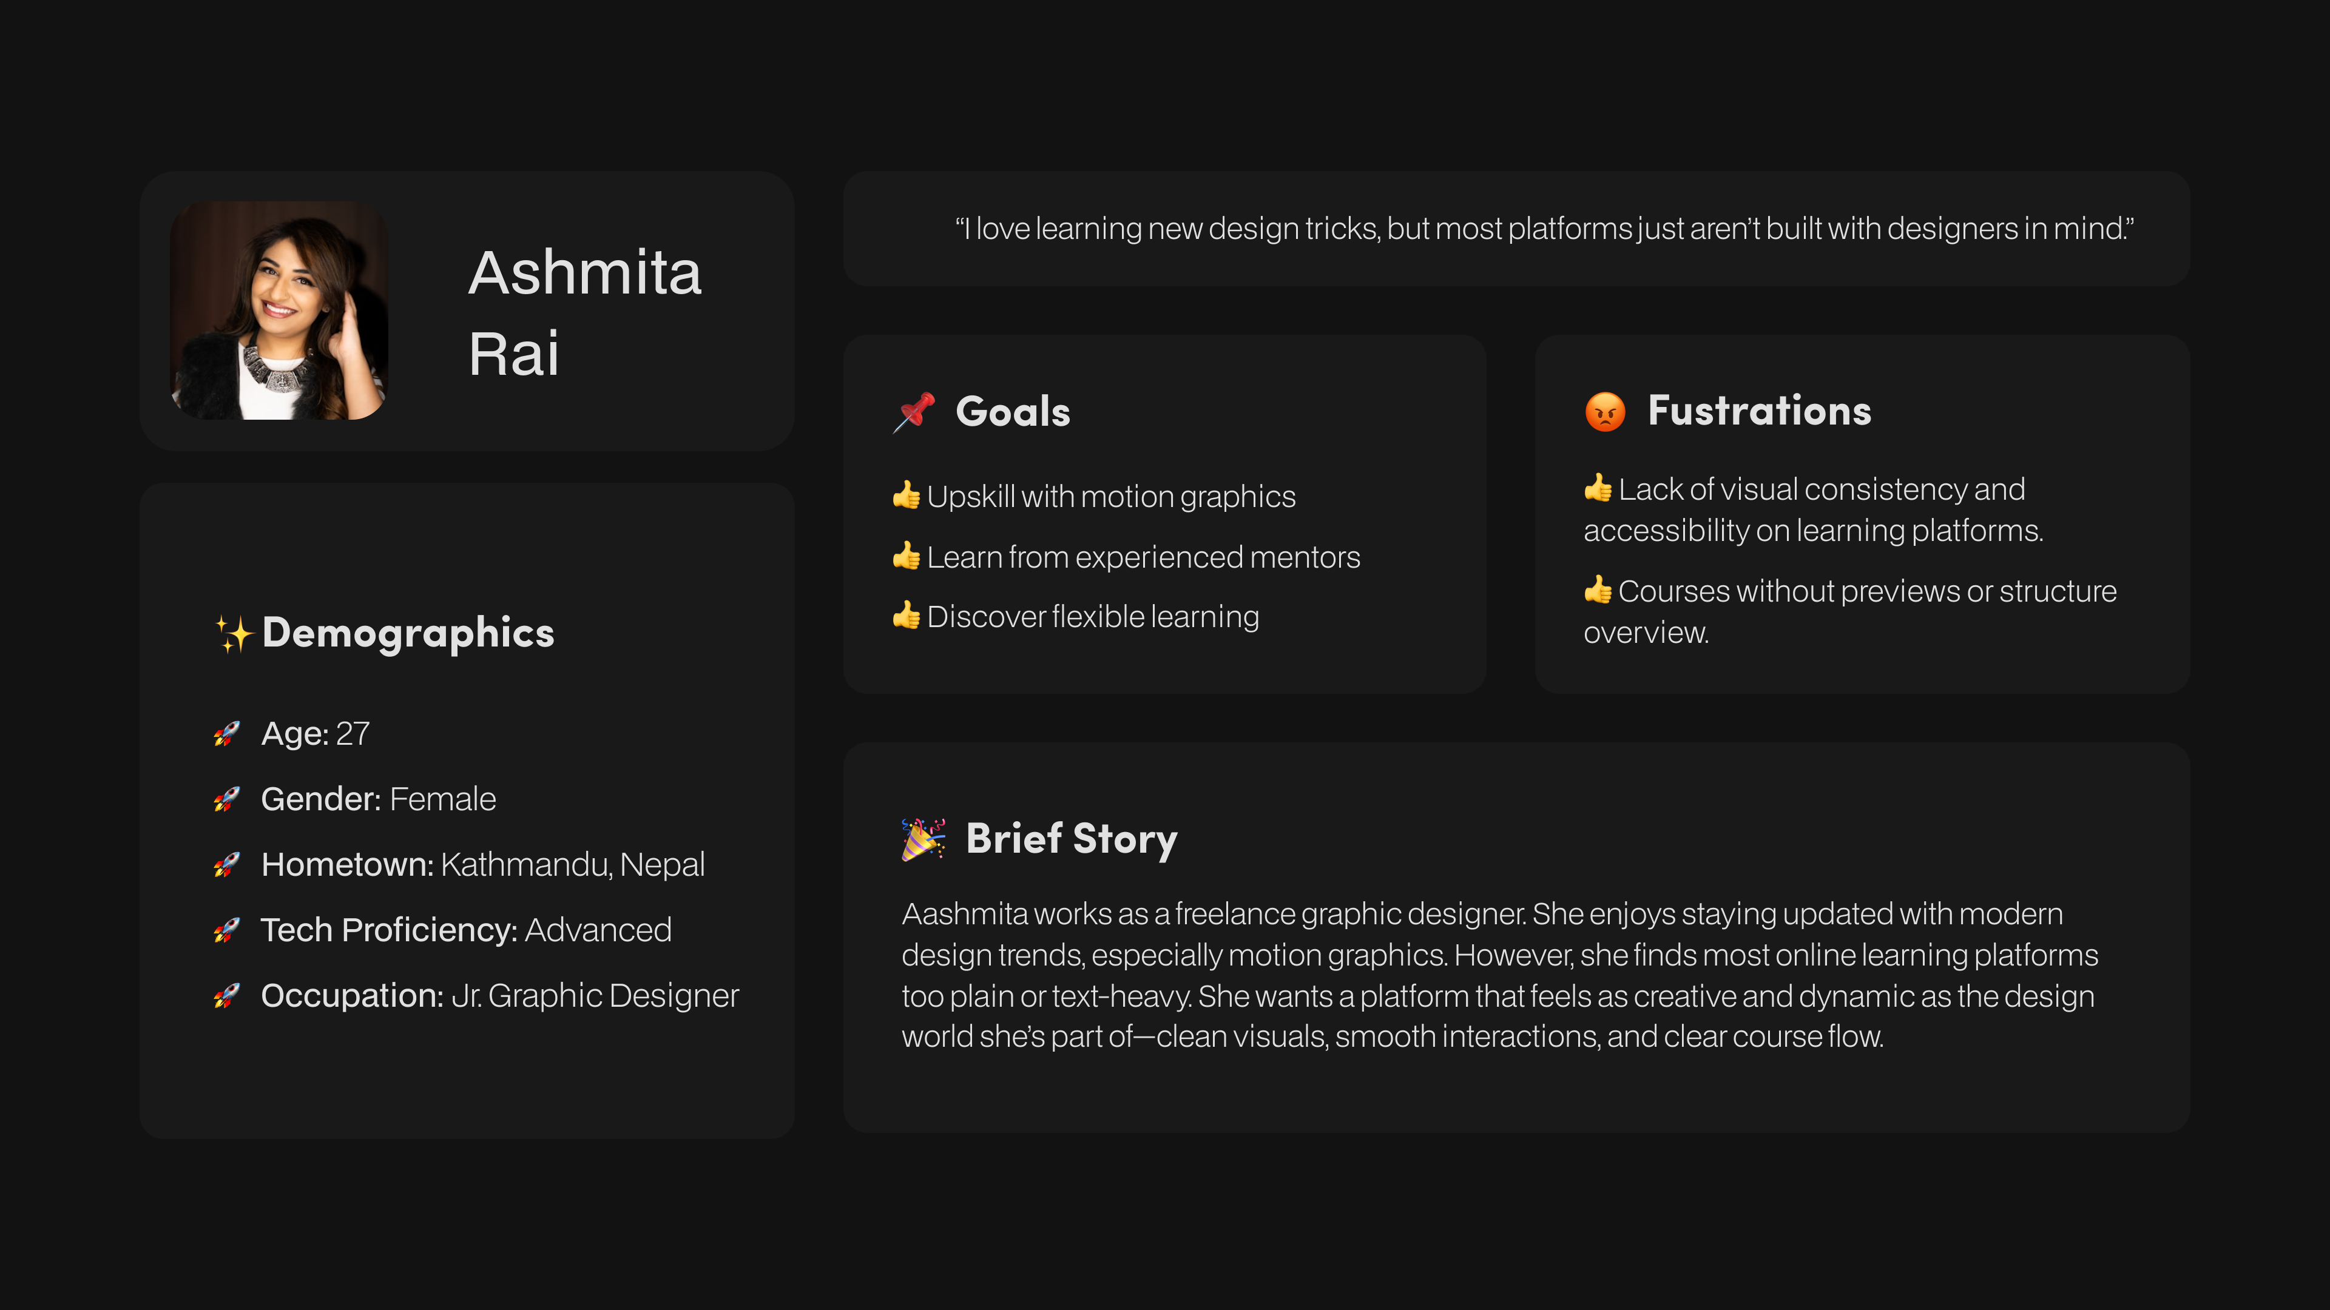

Figure 10: Asmita Rai

### Information Architecture

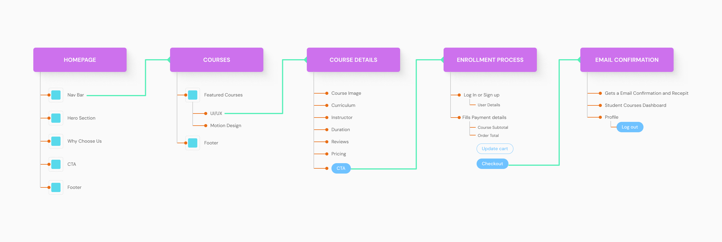

Figure 11: Information Architecture

### Sitemap

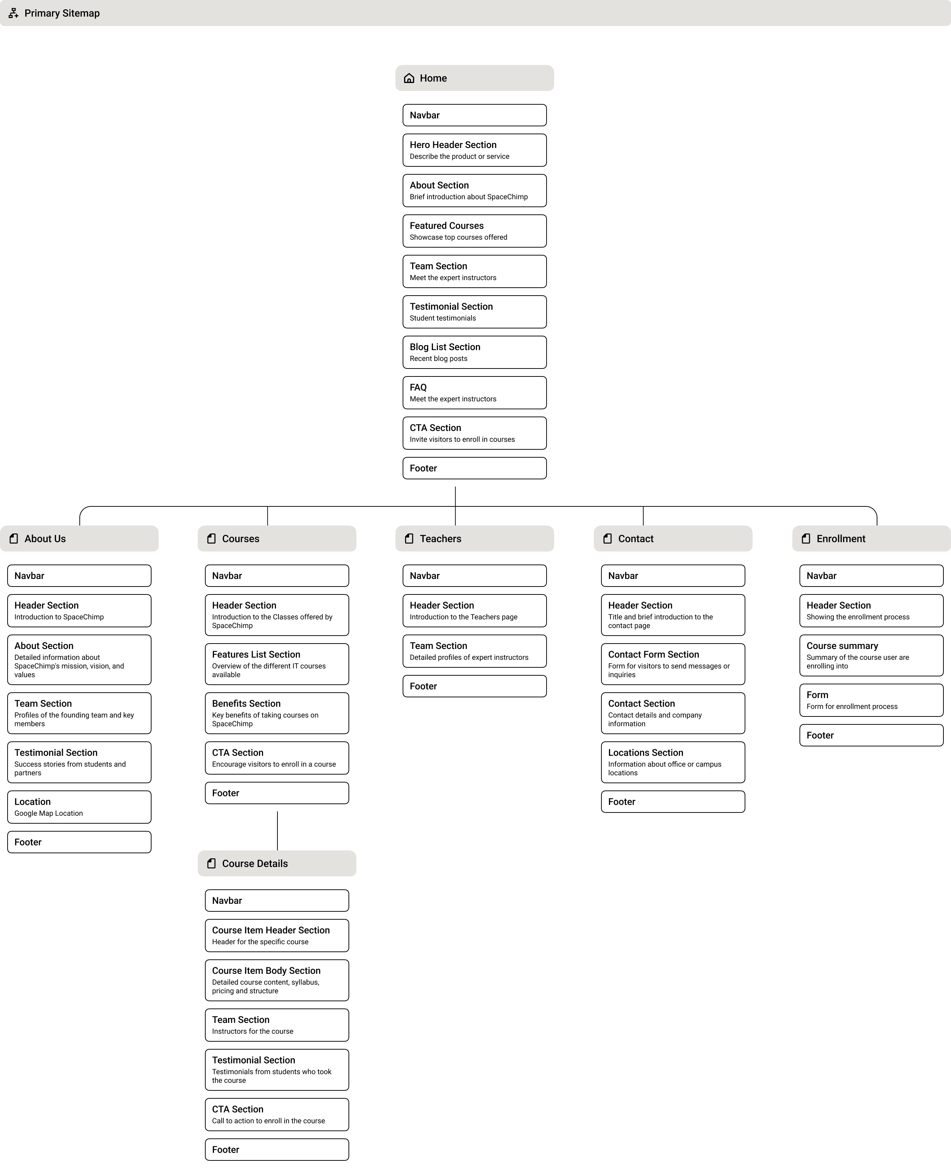

Figure 12: Sitemap

### Functional Specification Document

The SpaceChimp website offers its users access to five primary pages including Home and Courses and Instructors and About and Contact. Users can navigate through Home, Courses, Instructors, About, and Contact pages from the website. Users can access these pages through a top navbar that appears on every page of the site. Recipients can follow two main paths on the website - either click the logo in the navbar to reach the home page or experience visual highlights on active pages. All website pages hosts a footer section that provides direct links to major sections of the site.

**Home Page**

Users can navigate to featured courses and see instructor profiles and student feedback alongside contact buttons that direct them to explore learning materials and contact information. Responsive hover effects on cards along with delicate animations create a visually pleasant user experience while attracting user engagement.

**About Page**

SpaceChimp defines its mission alongside its vision and why spacechimp through the About page. Visual content shows brand identity along with platform purpose through selected sections. Simple on-click transitions enhance readability.

**Courses Page**

Users can view multiple course offerings through an organized presentation on this page. Each course box shows its name length and teaching contents with an learn more button for course detail page. Link interactions become visible when.hovering over the cards in order to provide users clear feedback. Users can smoothly view courses.

**Teachers Page**

The Teachers page provides information about SpaceChimp mentors together. Each teachers card presents an image along with their name and expertise area. The auto marquee animation on this page displays teachers profiecy in tech highlights dynamically. Smooth animations with simple transition between teacher on click interactions make the user experience more interactive through movements.

**Contact Page**

The Contact page presents at once all necessary contact details together with a simple form for submitting general inquiries. The platform provides users with a dedicated form they can use to contact spacechimp admins.

Across the site, consistent hover effects, microinteractions, and animation elements contribute to a clean, modern, and interactive experience that aligns with SpaceChimp's design-focused identity.

## Wireframing

After the sitemap was created Figma was used to to build low-fidelity wireframes according to the sitemap. Started by creating basic design maps that showed how users move through the platform and where content goes. These wireframes focused on visualizing navigation, user movement, and content placement free of visual design influences.

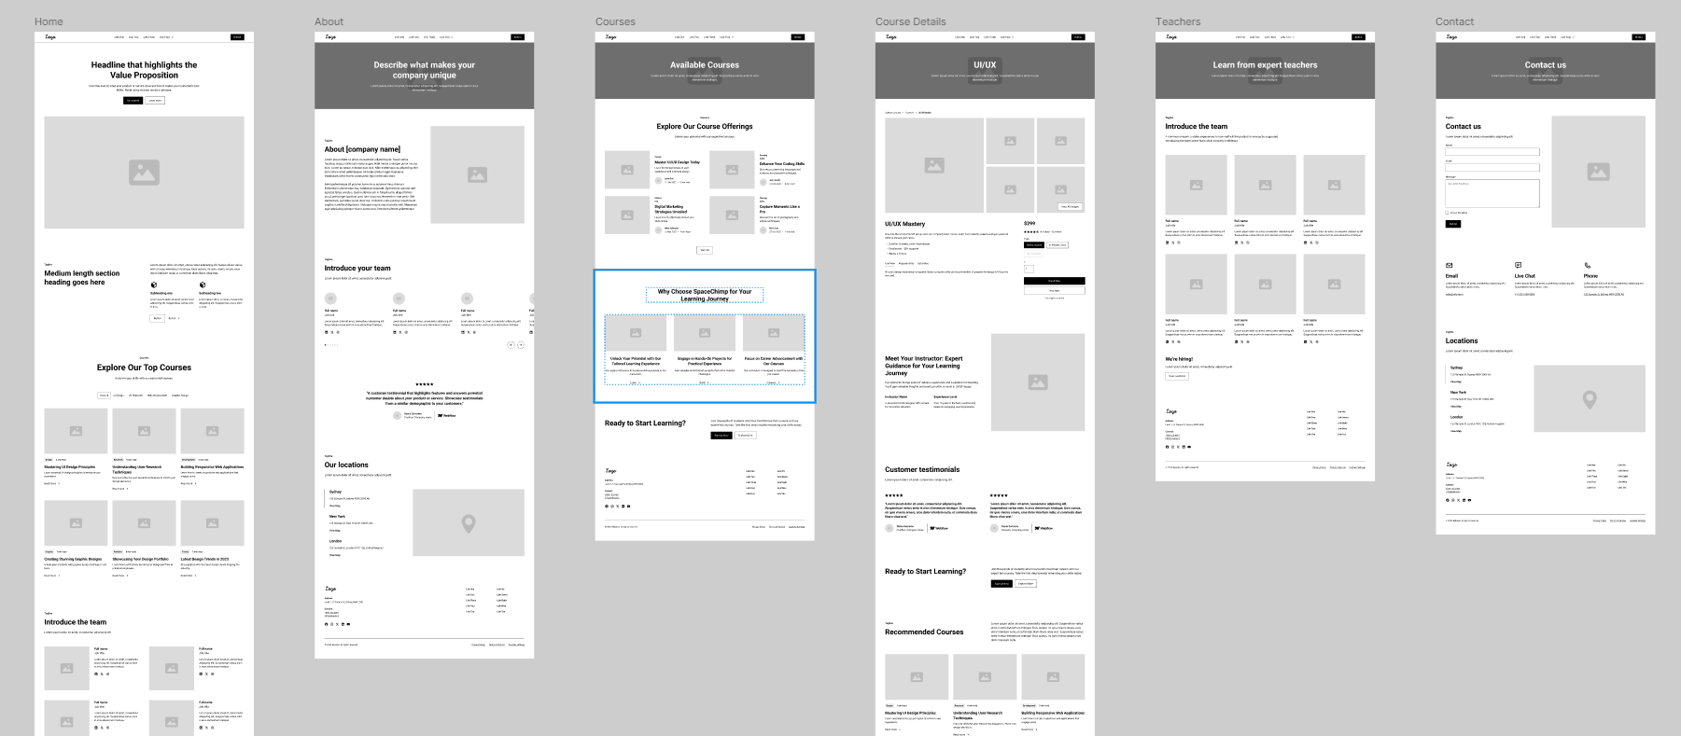

Figure 13: Low-Fi Wireframe

## Branding and Visual Identity

### Logo



Figure 14: Space Chimp Logo

### Typography

The website employed Clash Grotesk to display all headlines and titles thereby achieving an aggressive contemporary design. The designers selected Neue Montreal to serve both body text and buttons for maximum readability with a tidy design. A full typography style guide included designs for screens that ranged from desktop to tablet and mobile. The Figma Stark plugin performed accessibility tests to validate contrast and readability functions across various devices.

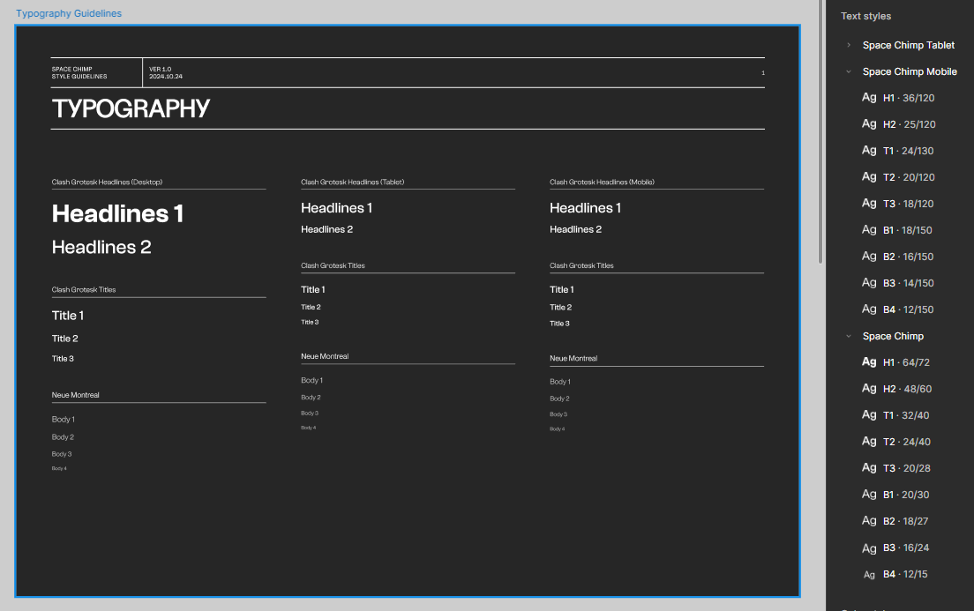

Figure 15: Typography Guidelines

### Color Palette

The client had shared the color palette of SpaceChimp which was thoroughly check for color contrast to verify that the colour passes the WCAG standard guidelines or not. It was crucial to check because many people with visual impairments can have problems with color that doesn’t pass through the WCAG Guidelines. Using stark plugin the Color were thoroughly tested to make the website accessible for all.

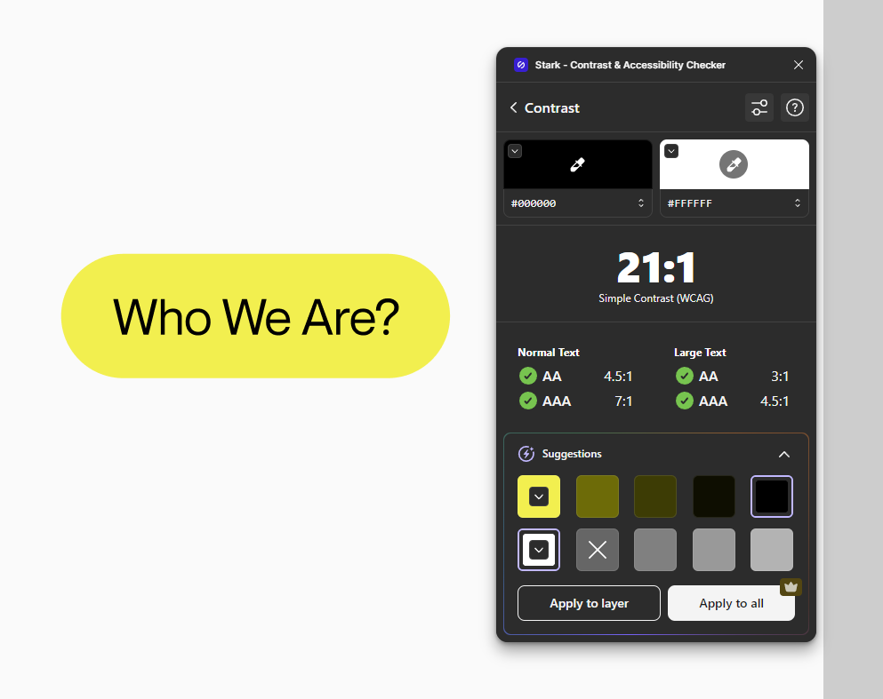

Figure 16: Color Accessibility Checking on Tag

### Illustrations and Assets

The Illustrations of mascot elements was provided by the client. The SpaceChimp mascot serves as an essential visual element which appears throughout different website sections including footers and navigation bars. The SpaceChimp mascot incorporating its distinctive design throughout the website gives visitors a pleasant and inviting experience. The mascot appears in multiple site sections thus strengthening the brand and enhancing user end retention.

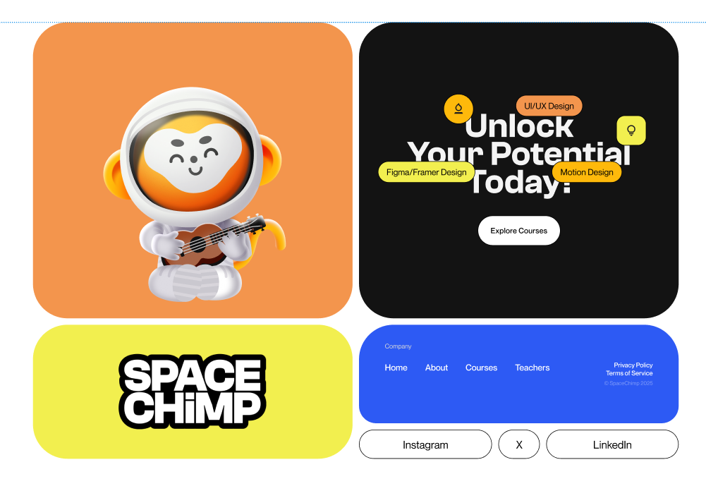

Figure 17: Mascot being utilized in footer

### Component System

Component Library: Reusable UI components such as buttons, navigation bar, footer, etc., were built to maintain consistency and speed up the design process.

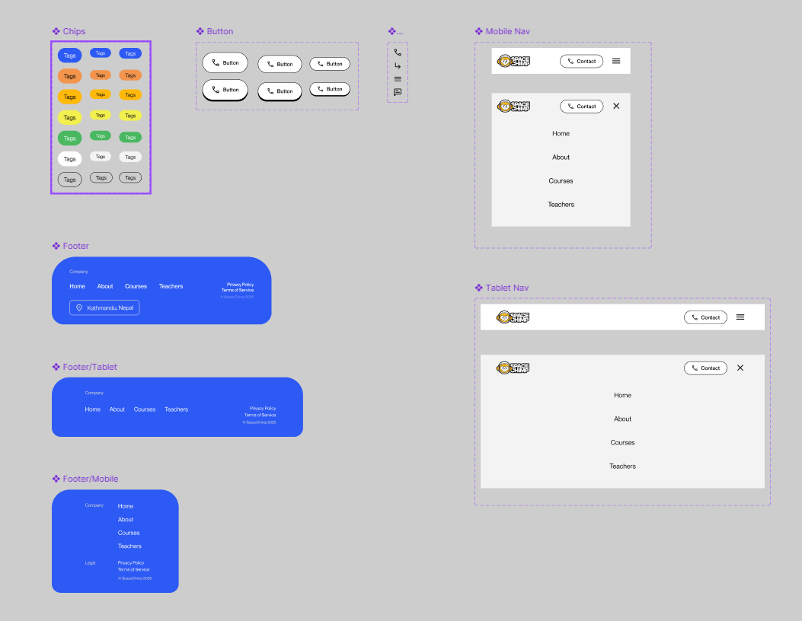

Figure 18: Components

## High-Fidelity Design

Figma was used for designing the High-Fidelity Design. This process includes the implementation of brand colours, typography and managing the content hierarchy.

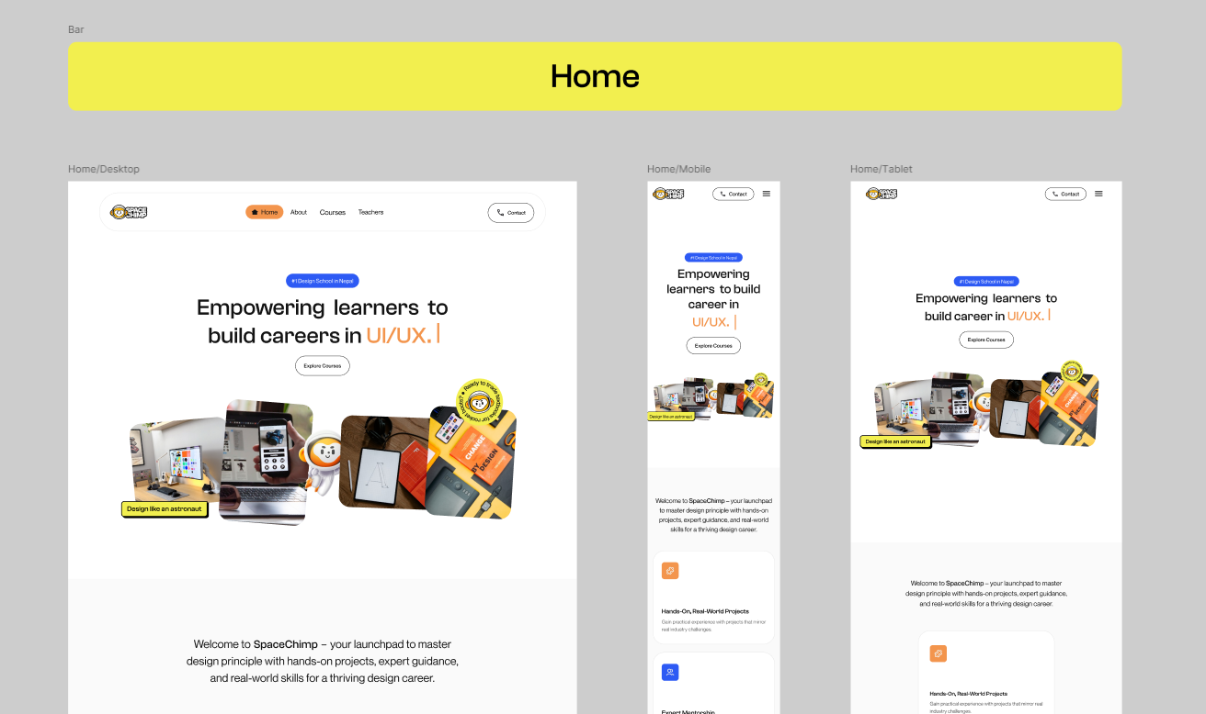

Figure 19: Home Page Hero Section (Desktop, Mobile, and Tablet)

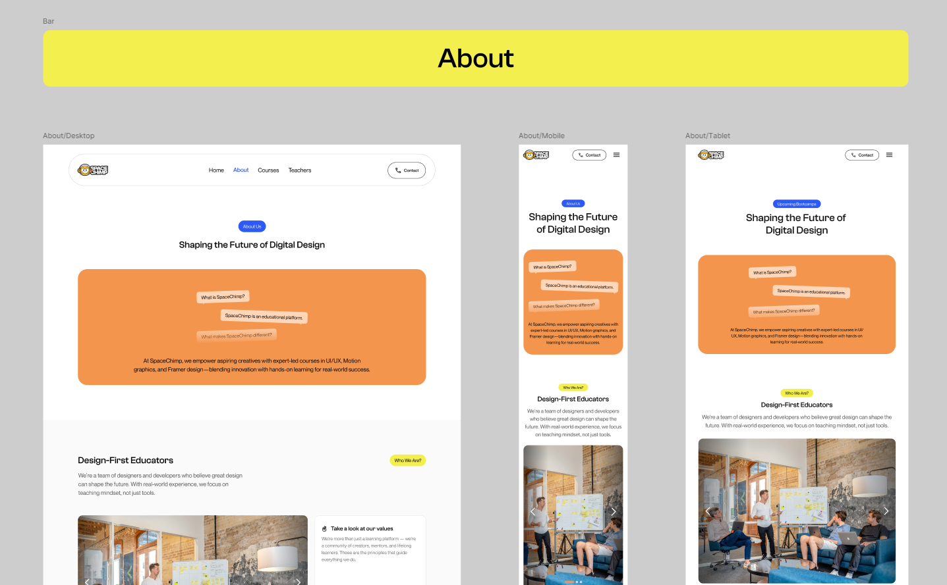

Figure 20: About Page Hero Section (Desktop, Mobile, and Tablet)

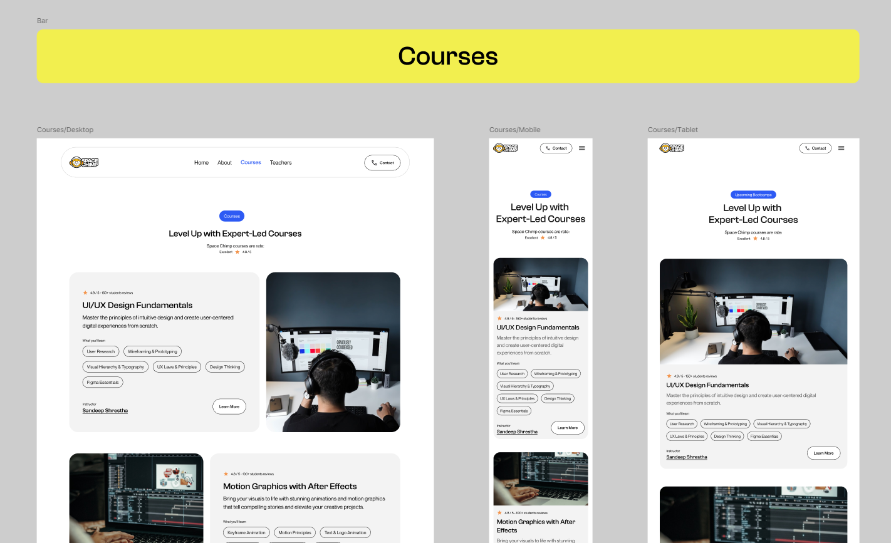

Figure 21: Courses Page Hero Section (Desktop, Mobile, and Tablet)

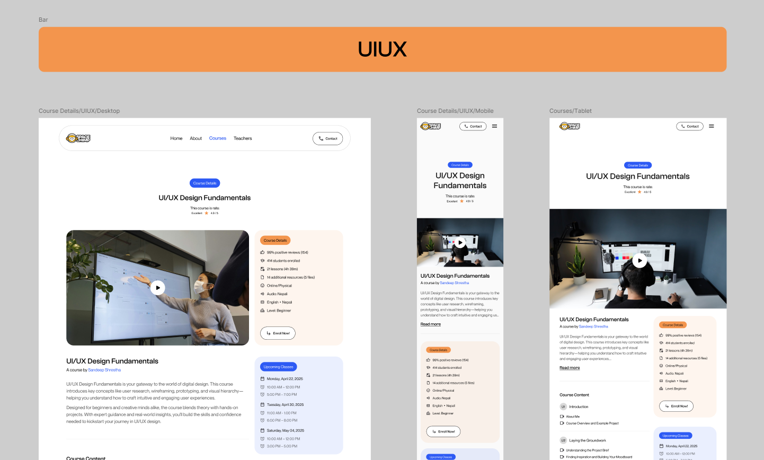

Figure 22: Course Detail Page Hero Section (Desktop, Mobile, and Tablet)

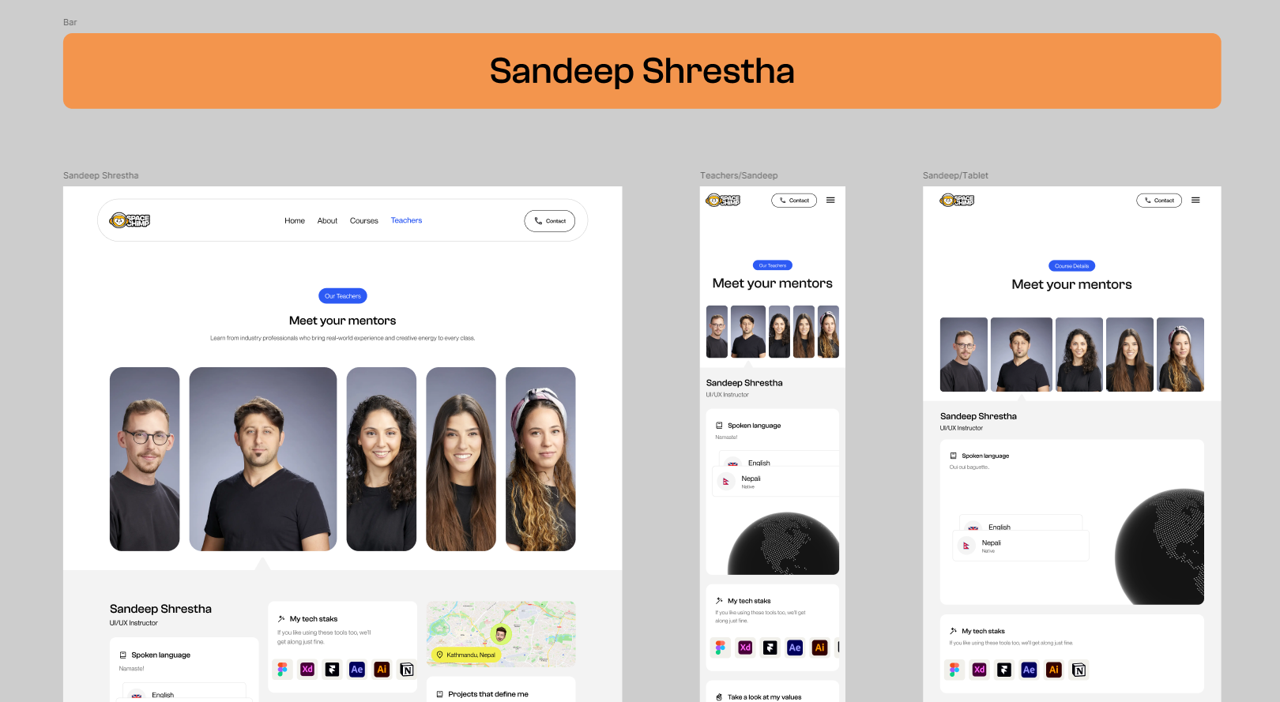

Figure 23: Teacher Page Hero Section (Desktop, Mobile, and Tablet)

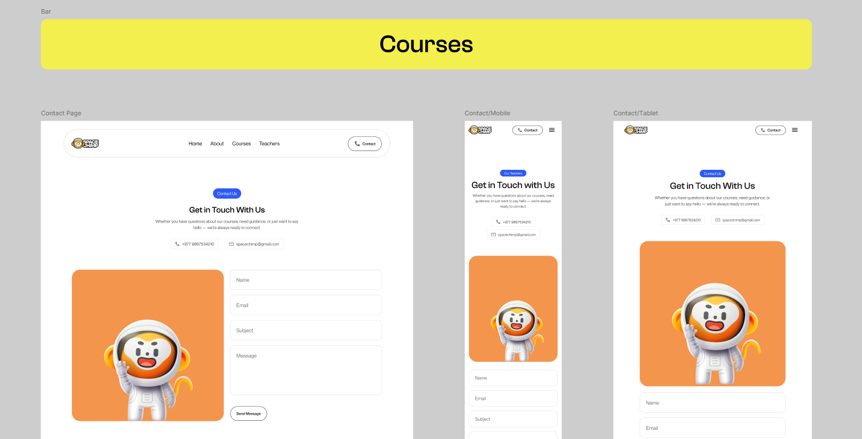

Figure 24: Contact Page Hero Section (Desktop, Mobile, and Tablet)

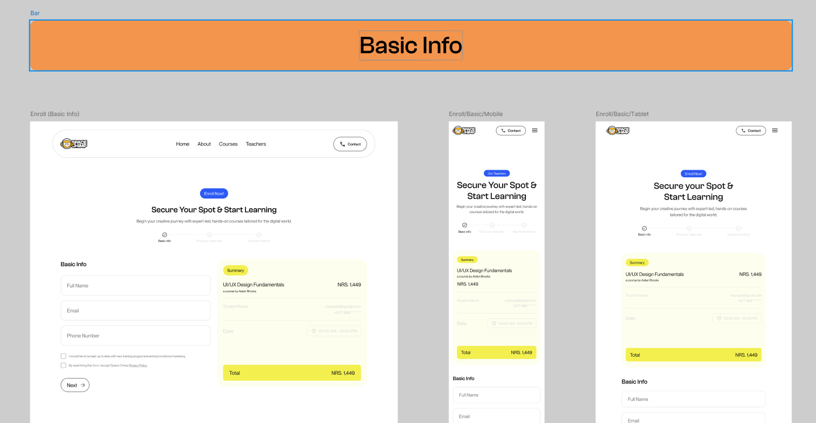

Figure 25: Enrolment Page Hero Section (Desktop, Mobile, and Tablet)

## Interactive Prototyping

Prototyping has been done in Figma by navigating all the links and buttons to their right pages along with some simple animation to get a realistic feel of the final product. This prototyping has helped to do user testing and get early feedback for refinements.

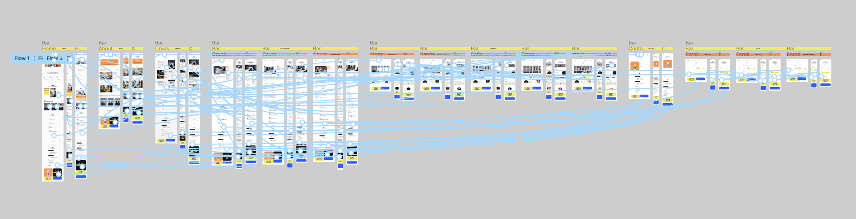

Figure 26: Prototyping

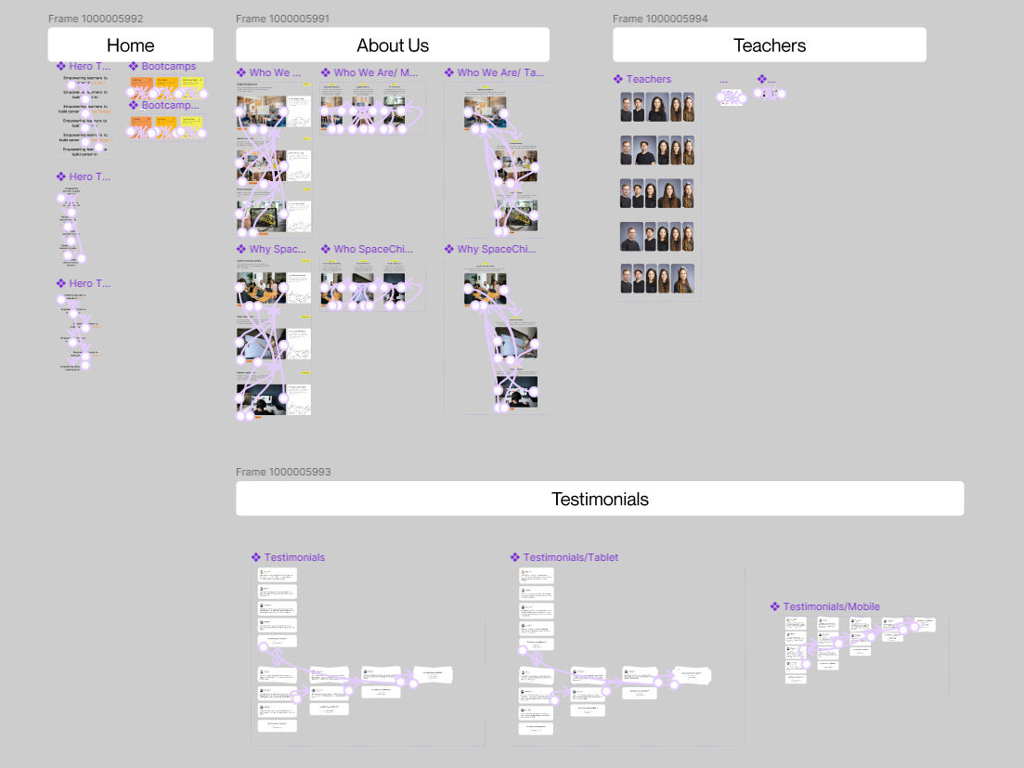

Figure 27: Animation

## User Testing and Insights

A user testing session was evaluated to test both the effectiveness and usability along visual look of the SpaceChimp website. The evaluation examined how the website design combined with user reception in addition to content readability and website functionality. Users performed tests with the deployed prototype and through an established Google Form questionnaire session.

Twenty participants from various demographic groups representing different industries along with diverse device orientations conducted the testing. A combination of demographic information and detailed questions about the user interface, visual design along with usability assessments were included in the questionnaire.

**The main areas of evaluation included:**

1. **Understanding the demographics of the participants**

* Participants aged 18–24 made up the majority of users at 55% while those under 18 represented 45% of the total sample.
* Males made up the largest participant group at 75% while others and females followed.
* Research participants represented three distinct fields where 50% were students within education alongside 35% who worked in creative and design and 15% pursued careers in tech development.
* Desktop devices were used by 55% of participants whereas 25% used mobile and 20% used tablet devices for their interactions.

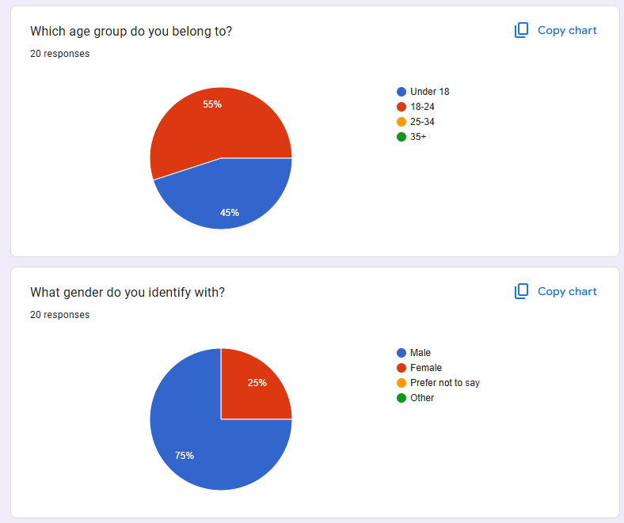

Figure 28: QA Result 1

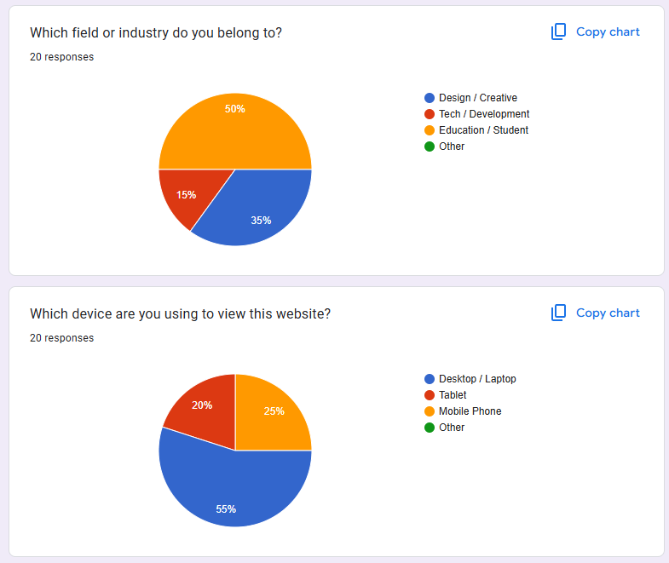

Figure 29: QA Result 2

1. **Initial impression of the landing page**

* Participants responded positively to the homepage design:
* The website's first glance received strong positive feedback from 75% and received neutral reactions from the remainder.
* The homepage effectively communicated organizational purpose according to 85% of respondents even though a couple said it had unclear messaging.

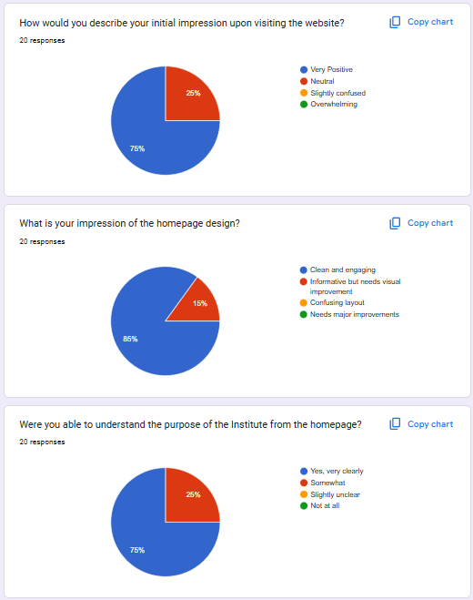

Figure 30: QA Result 3

1. **Analysis of navigation and usability across the website**

* Users found navigating the website simple 85% of the time even though some believed it needed improvements.
* Page loading and elementialization provoked no issues for 90% of users yet minor obstructions were recorded by 15%.
* A significant number of users (85%) found the website's contact form easy to use.
* The participants graded the website navigation system mostly between 8–10 points on a navigation ease scale.

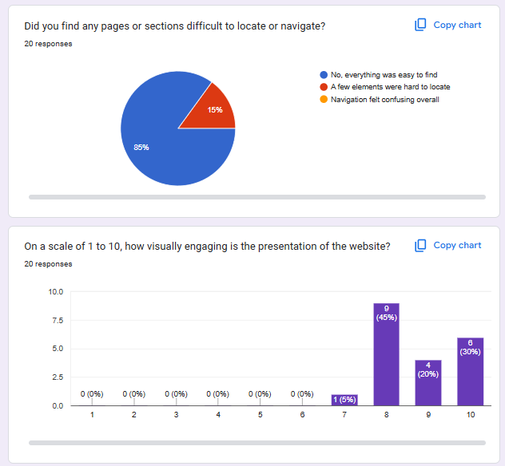

Figure 31: QA Result 4

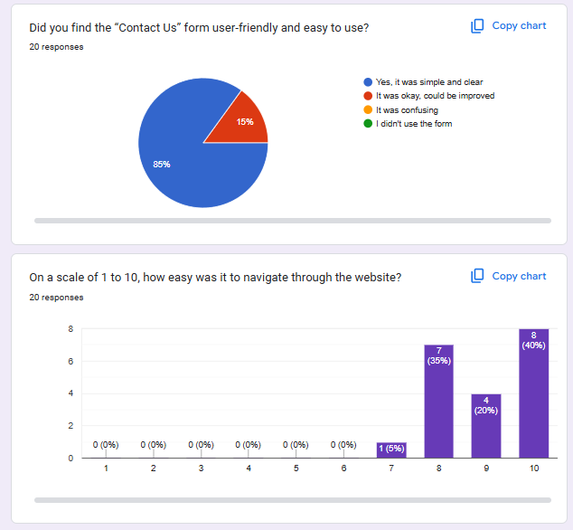

Figure 32: QA Result 5

## Final Evaluation

### Self-Evaluation

I found the experience of working on SpaceChimp website to be truly satisfactory. Every development step of the project delivered fresh obstacles and educational insights. The main investigative question "*How can responsive, adaptive, and accessible design collectively improve user engagement and inclusivity on educational websites?* " about design approaches for educational platforms shaped every aspect of project development toward maximizing user engagement and inclusivity.

To ensure a smooth experience regardless of device type adaptive design was created adjusted automatically. By giving specific attention to accessibility by evaluating elements like color contrast and text to provide usable interfaces for users with diverse needs.

The initiative paid special attention to both the visual representation and the usability dimension of the system. All design decisions starting from system arrangements up to text styles and artwork selection function to promote educational practices while sustaining user engagement. Continuous feedback from users and client testing enabled to enhance sections that required improvement. The project revealed proper design goes beyond mere aesthetics because it needs to serve every individual effectively.

### Third Party Evaluation

#### Aryan Shrestha – Jr. UIUX Designer



Figure 33: Aryan Shrestha

The entire design of SpaceChimp website presents a contemporary clean style. The strong brand identity emerges immediately from the landing page because the mascot illustrations maintain consistent use throughout. The platform maintains a professional and creative note through its chosen fonts while its layout and typography structure facilitates simple content scanning.

I liked how the platform updated for different screen sizes because it maintained visual continuity throughout. The padding within some sections on smaller mobile screens appeared too close together so it decreased readability to the point where adjustments would benefit display. The transitions as well as the hover effects appeared subtly yet effectively. Users experience a responsive interface which feels engaging without becoming cluttered.

#### Parkash Shrestha – Developer

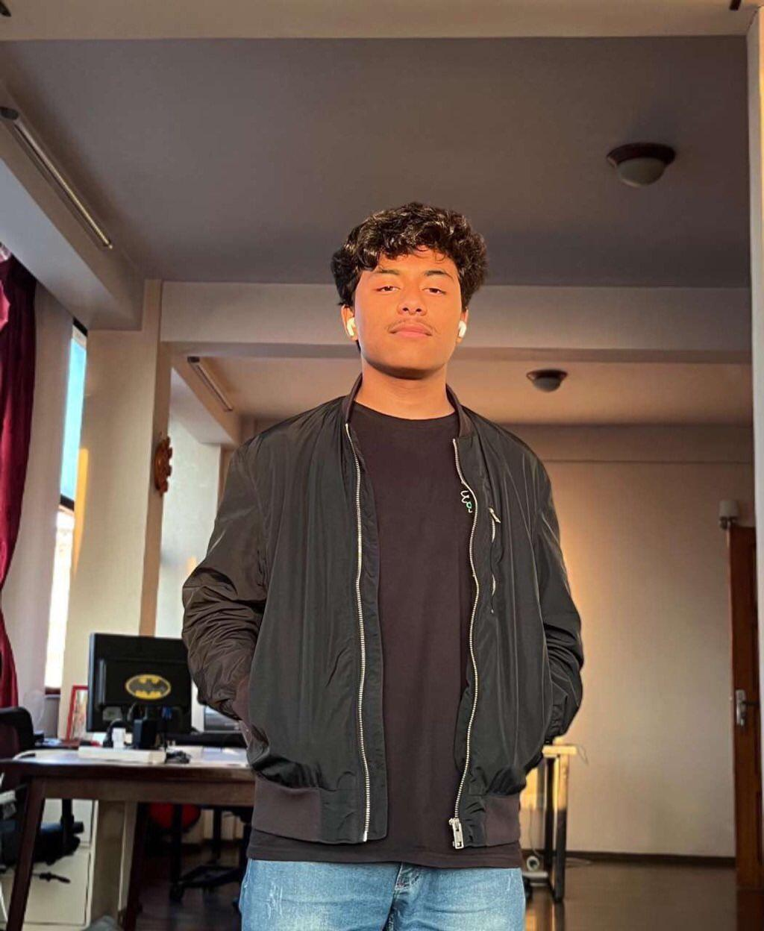

Figure 34: Prakash Shrestha

From the develop perspective I find the SpaceChimp website both structurally sound and technically sophisticated. The website demonstrates responsive design features through its fluid performance across multiple screen dimensions implemented through media queries. The interface maintains proper alignment across all screen sizes from desktop to tablet and mobile which is among my key inspection areas.

One minor note: Slower internet speeds result in delayed loading of image-heavy sections so lazy loading would enhance performance. The project demonstrates solid understanding of design and development principles with a positive focus on accessibility since its initial planning phase.

# Conclusion

The final project successfully reached its outlined objectives according to documentation. The project – “SpaceChimp” has addressed the research question: “How can responsive, adaptive, and accessible design collectively improve user engagement and inclusivity on educational websites?” All phases from research to design as well as prototyping and product testing are fully documented in this record.

Figma was used to create wireframes along with high-fidelity prototypes as well as animations and components during the design phase.Stark plugin was used for accessibility checks while analyzing responsive design with browser developer tools (google inspect element). Stylescape along with a site map was designed to preserve layout consistency and branding elements and typography standards across the design.

The completed digital product presents SpaceChimp's unified brand message alongside a user experience that remains straightforward and accessible. Users and project goals both benefited from the final design which achieved recognition from the target audience.

All project requirements for designing and producing digital media delivery were achieved successfully. The prototype website was showcased to users who provided feedback which helped improve the final design output. The final design received positive feedback from users while achieving all project requirements and user needs.

# Bibliography

*Interaction Design Foundation*. (n.d.). Retrieved from https://www.interaction-design.org/literature/article/should-you-choose-between-responsive-and-adaptive-design

# Appendix

